**ID: 23058**

**NAMES: MASHAMI Pacifique**

**Language: PYTHON (DJANGO FRAMEWORK)**

WEB TECHNOLOGY PROJECT

**PRESCRIPTION WEB APPLICATION FUNCTIONAL & NON-FUNCTIONAL REQUIREMENT**

**FUNCTIONAL REQUIREMENT:**  How application will behavior under specific conditions

**A NORMAL USER OR** **PATIENT**

* The system will request a user to create an account by enters personal information.
* The system will sends an approval request on his/her email after the user enters personal information.
* The system will request a user to log in if he/she has an account by using Email and password.
* The system will request an email if a user forget password.
* The system will sends a token number on email in security purpose.
* The system will allow a user to list all medicines doctors propose.
* The system will not allow a user to modifier a list of medicines.

**HOSPITALS**

* The system will Its self register hospitals want to work with it.
* The system will allow a doctor to have the interface for doctors.
* The system will allow a doctor to prescribed Patients medicines.
* The system after doctor save a list of medicines will send to a patient account.
* The system will allow a doctor to modifier prescription for a patient.

**PHARMACY**

* The system will allow a pharmacy to create an account to our system.
* The system will allow a pharmacist to view a list of medicines doctor has prescribed.
* The system will allow a pharmacist to disable medicines has recorded.
* The system will keep medicines records in database but will be hidden on user interface.

**NON-FUNCTIONAL REQUIREMENT :** describe the general properties of a system. They are also known as quality attributes.

* The system will allows a user to use our web application by providing email and password to log in system.
* The website pages should load in 3 seconds with the total number of simultaneous users <5 thousand.
* The website page for list medicines for user will be maximum 10 records each page.
* The system should be able to handle 20 million users without performance deterioration.
* The system should be able to classifier users on their interfaces only.
* The system should not be allow a user to modifiers his prescription.
* The system should be providing date of actions.
* The system should be providing security to there users.
* The system should be able to providing the hospitals names where prescription comes from.
* The system should be able to allow administrator to manage the system.
* The system will allow a user to log in by using their google account.

**PROGRESS**

Home page:

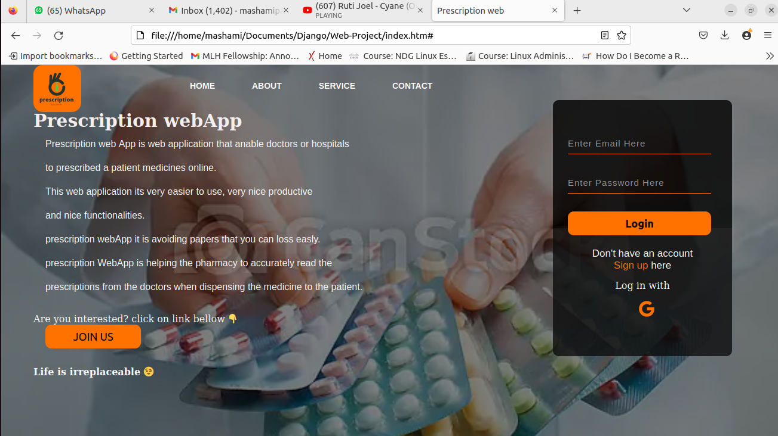

This is home page where user will log in on this page.

Log in field required is : -Email

- password

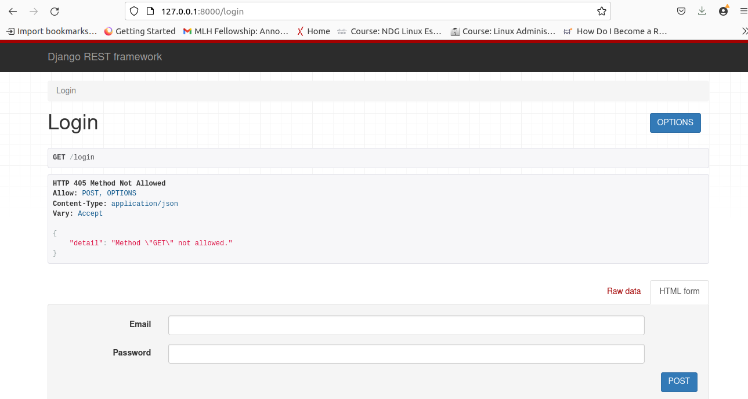

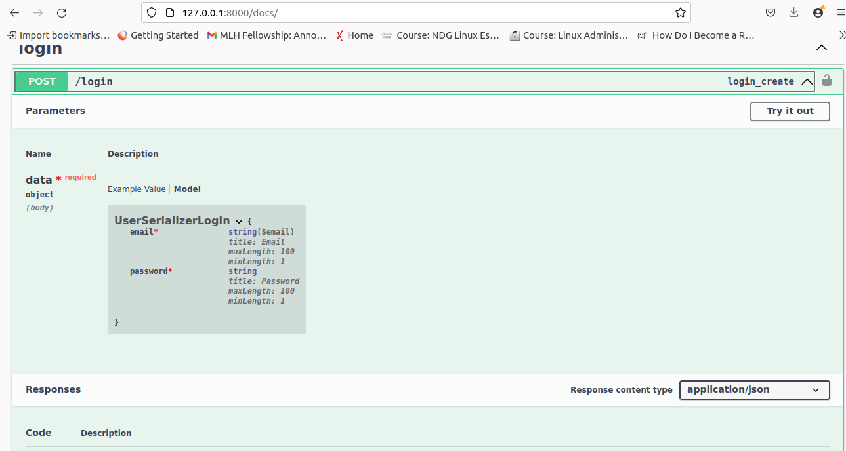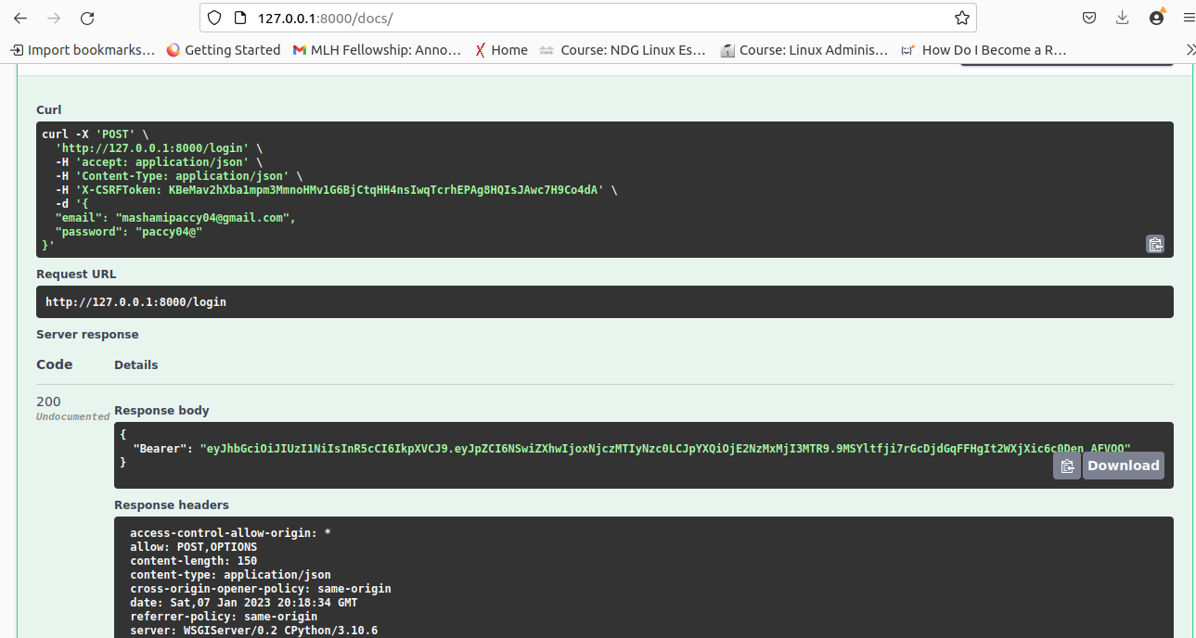

**After log in system will genelate token (Bearer or jwt)**

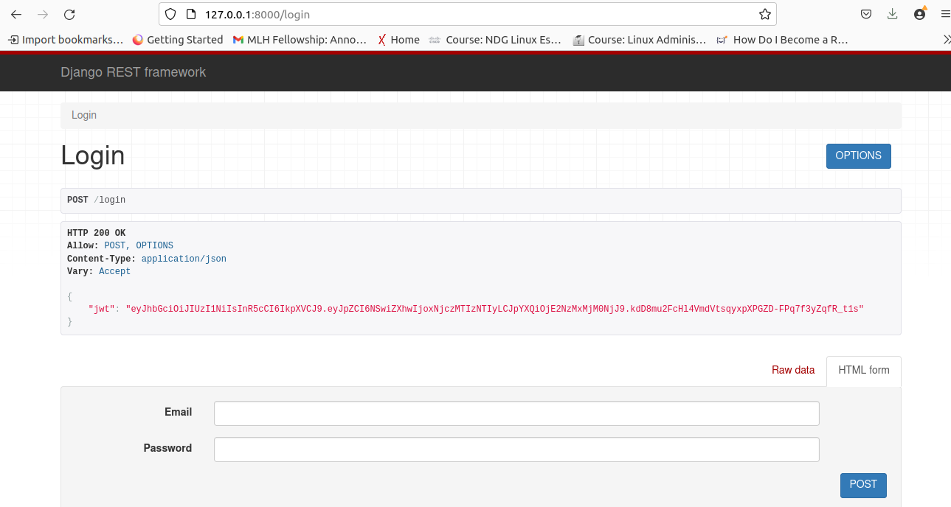

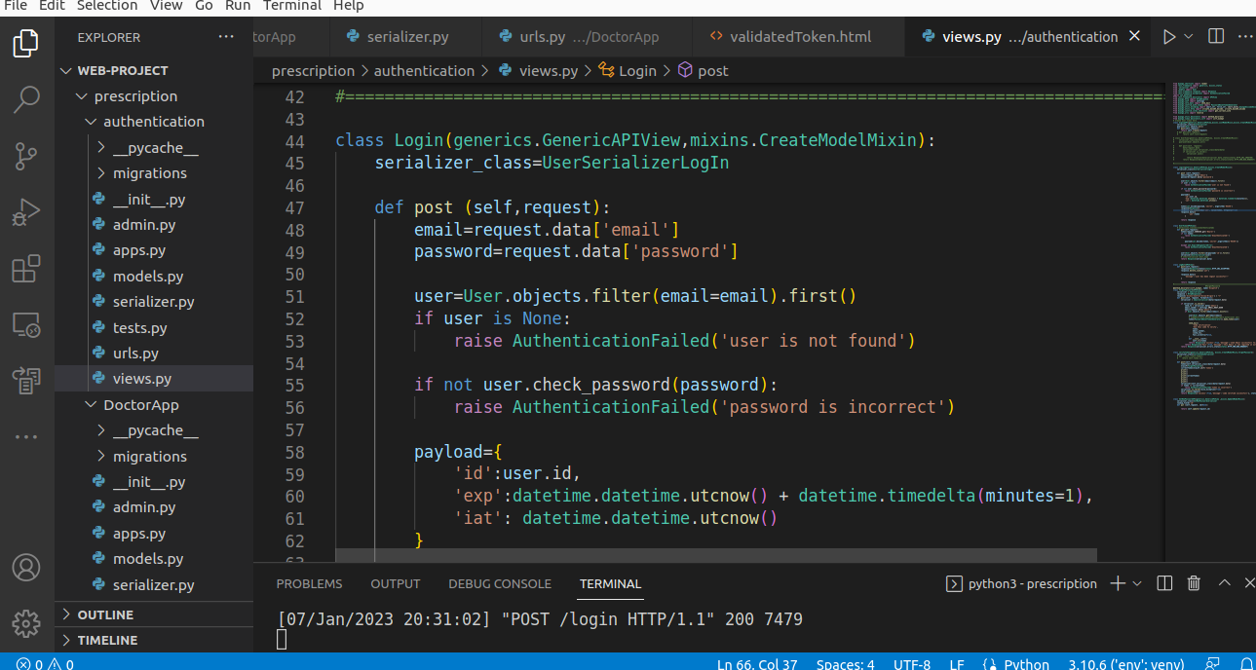

Those user who don’t have an account in our system, system will allow them to create accounts

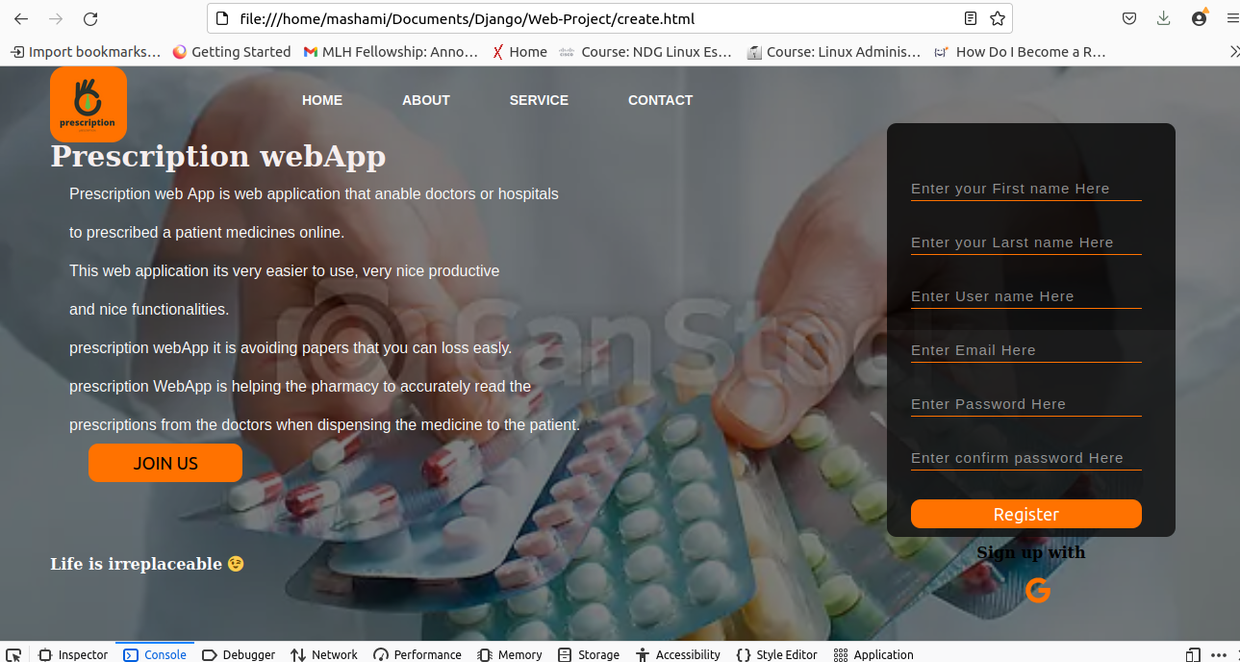

**they can also use google account to log in**

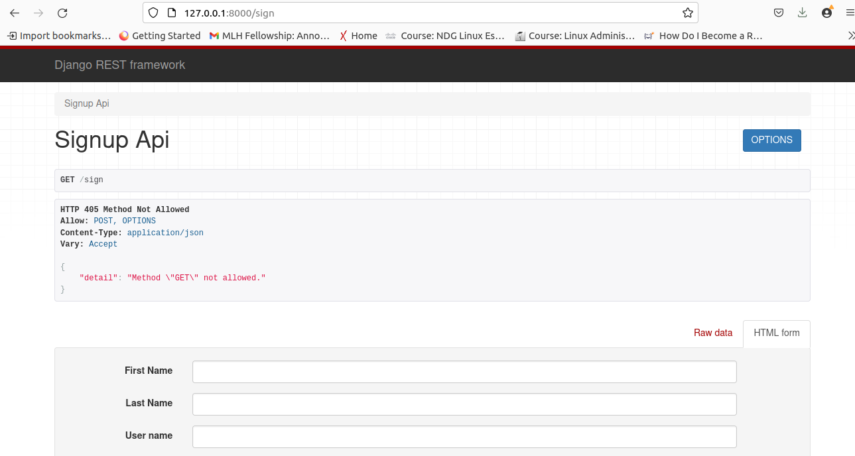

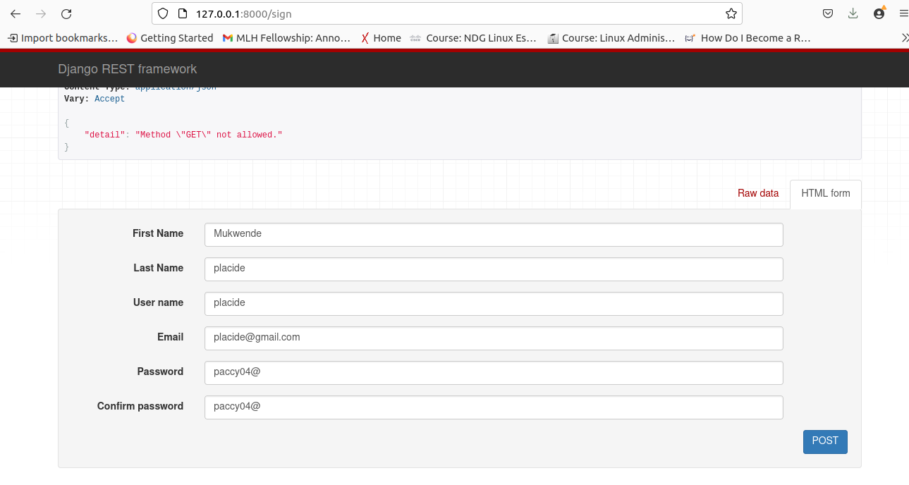

after hit POST

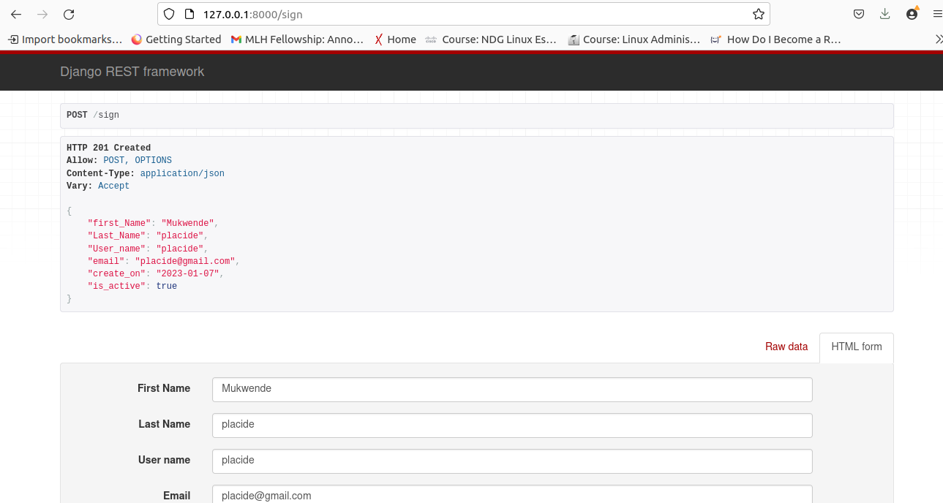

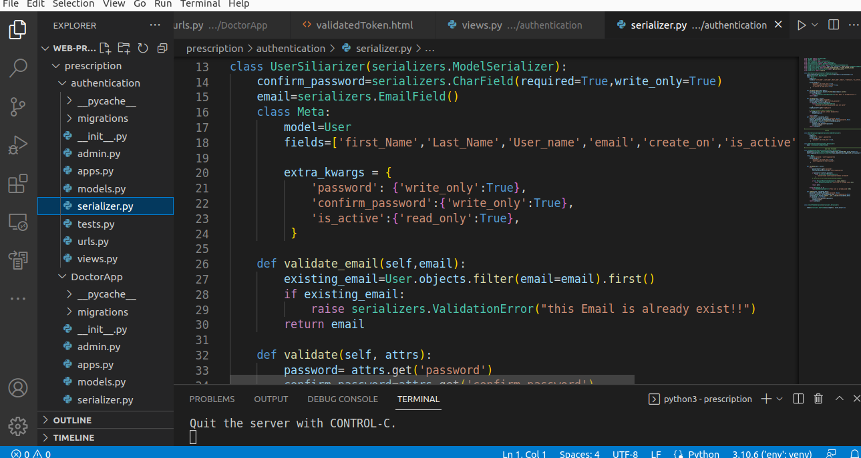

Those are the codes I used in creating a user

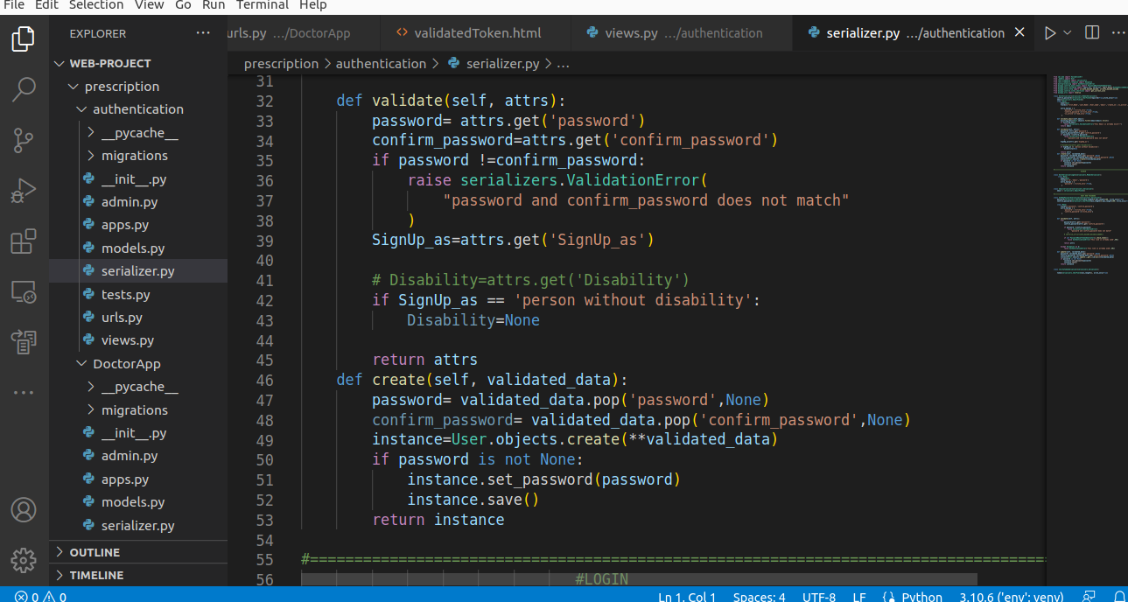

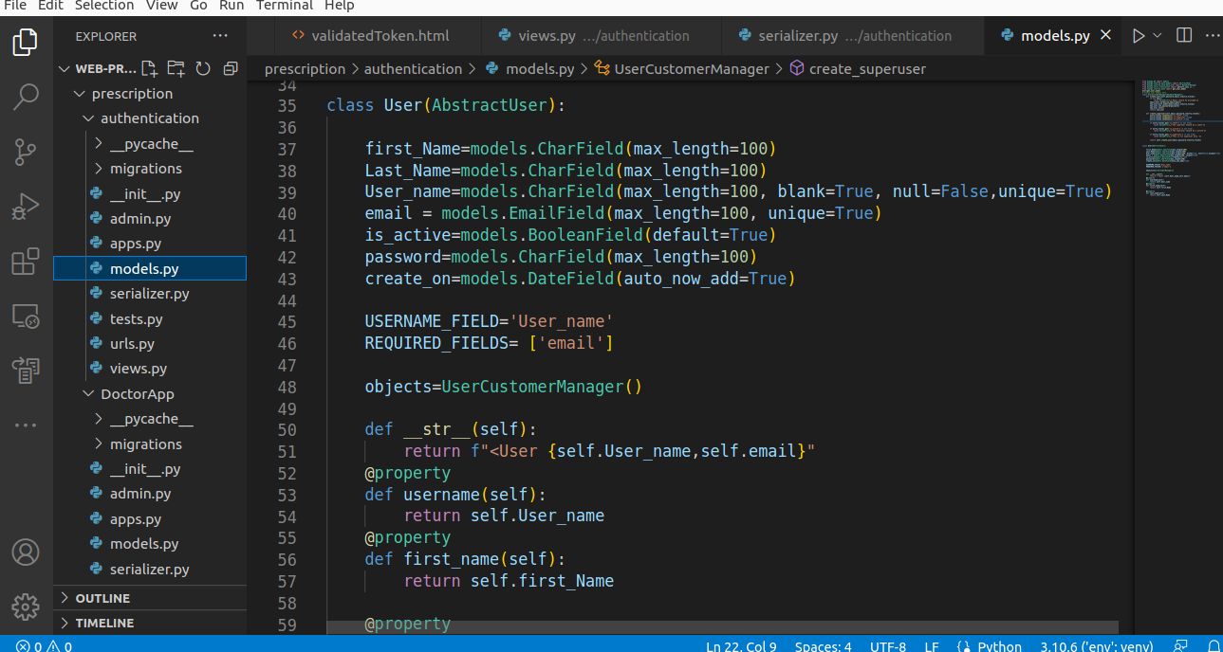**This is the MODEL.**

**If the user forget password the system will allow him/her to create another after verify is exit**

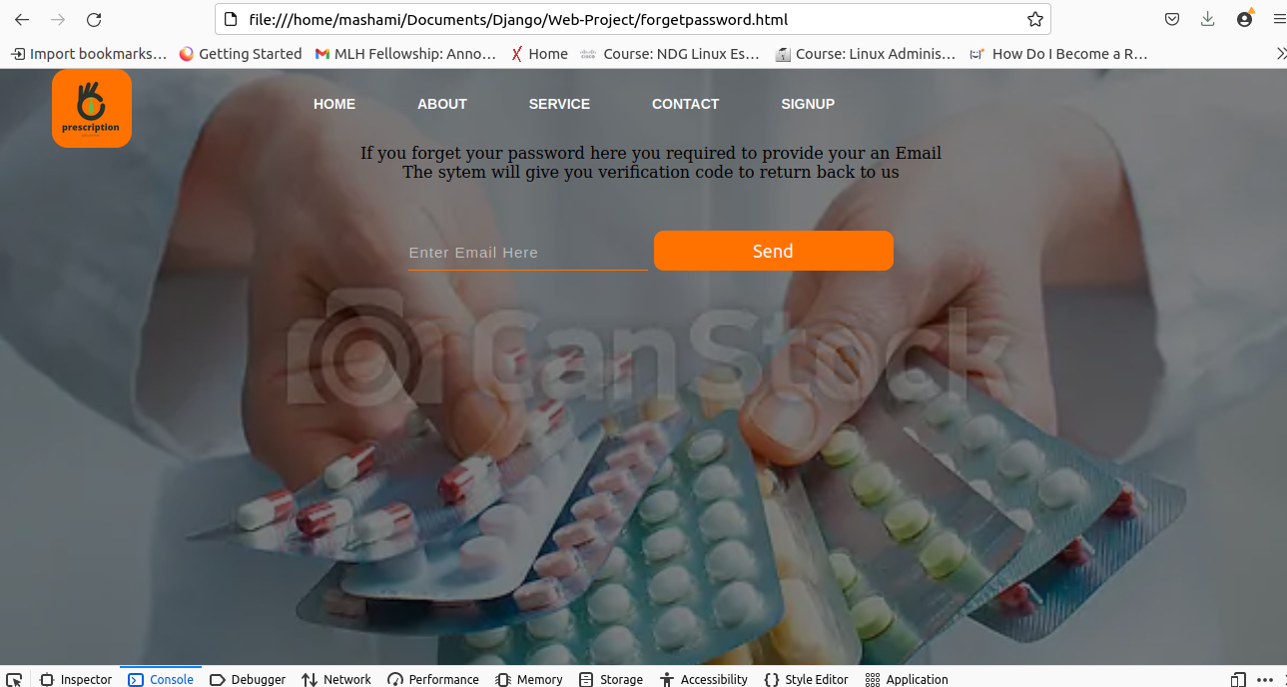

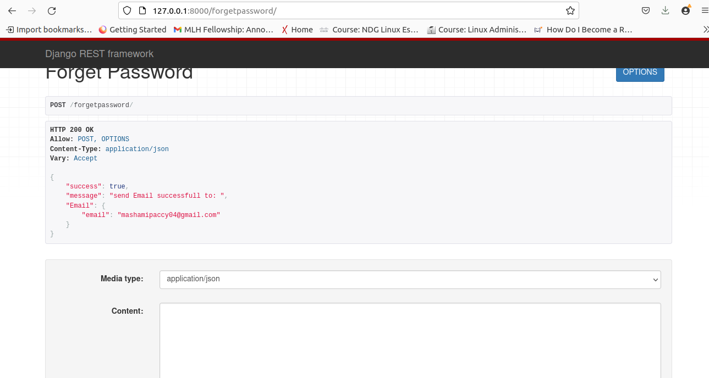

**This is the token received in your Email accounts to used to verify if is 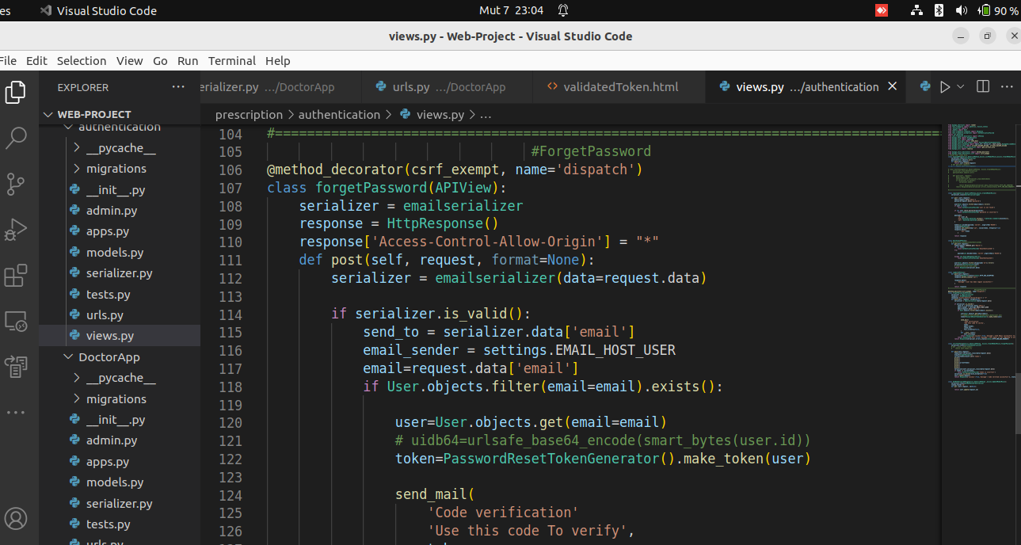really yours.**

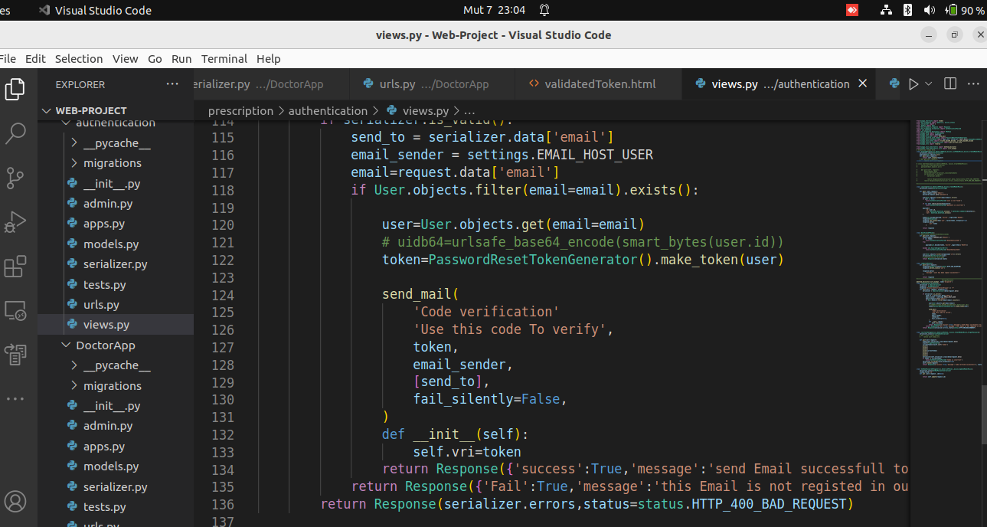

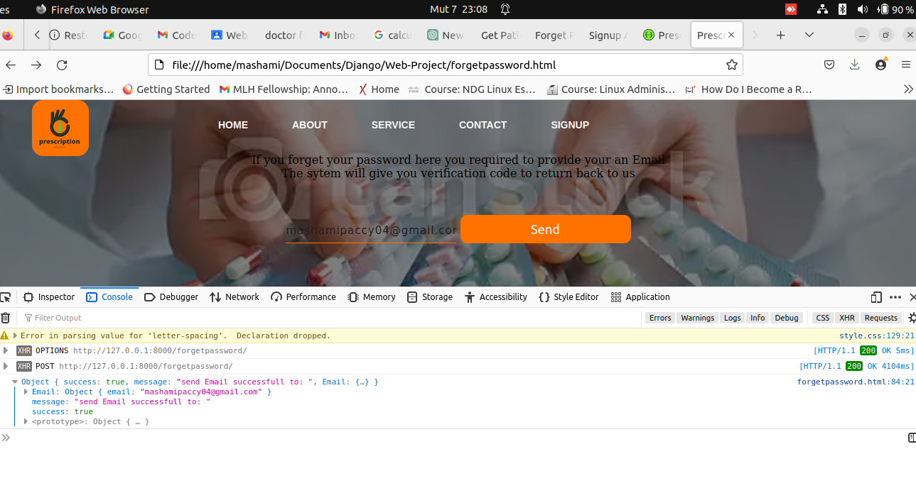

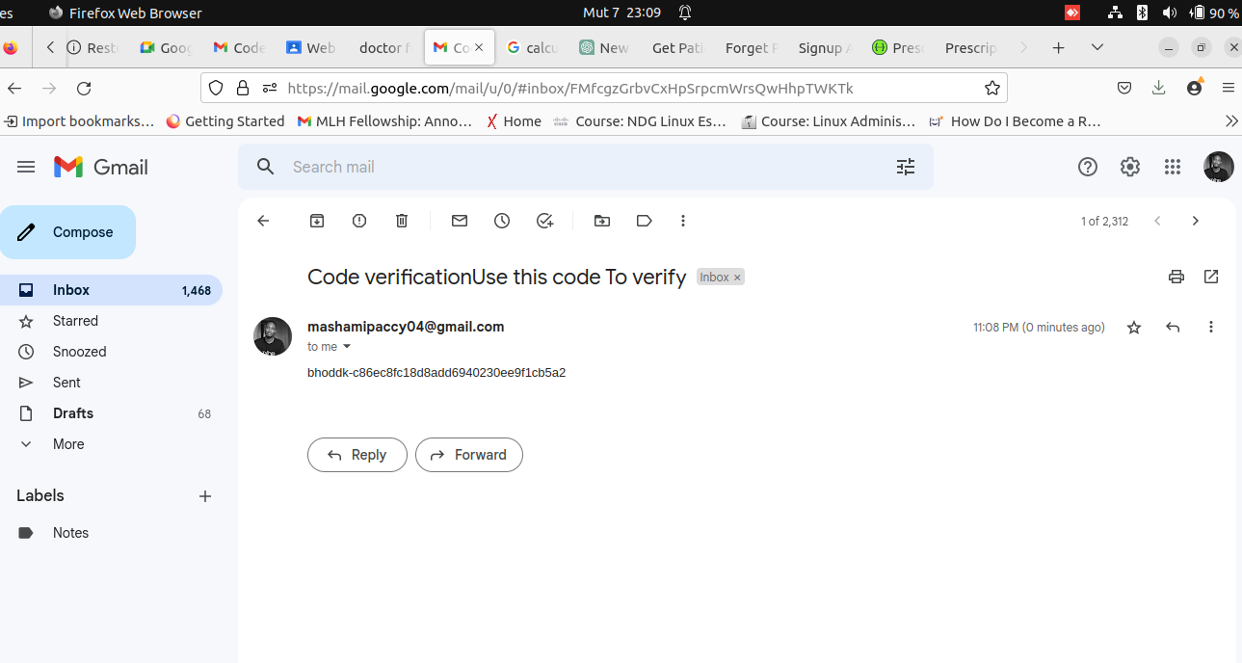

**The system will redirect to validation a user after getting an email**

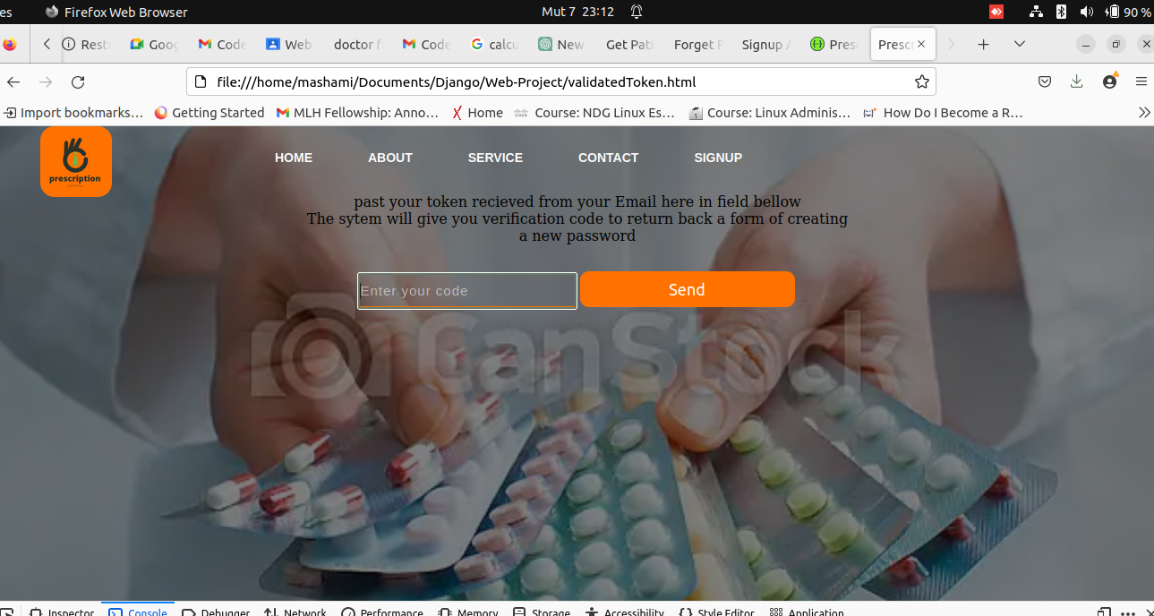

**THE USER WILL BE ABLE TO READ ABOUT US WITH NO NEED AUTHORIZATION**

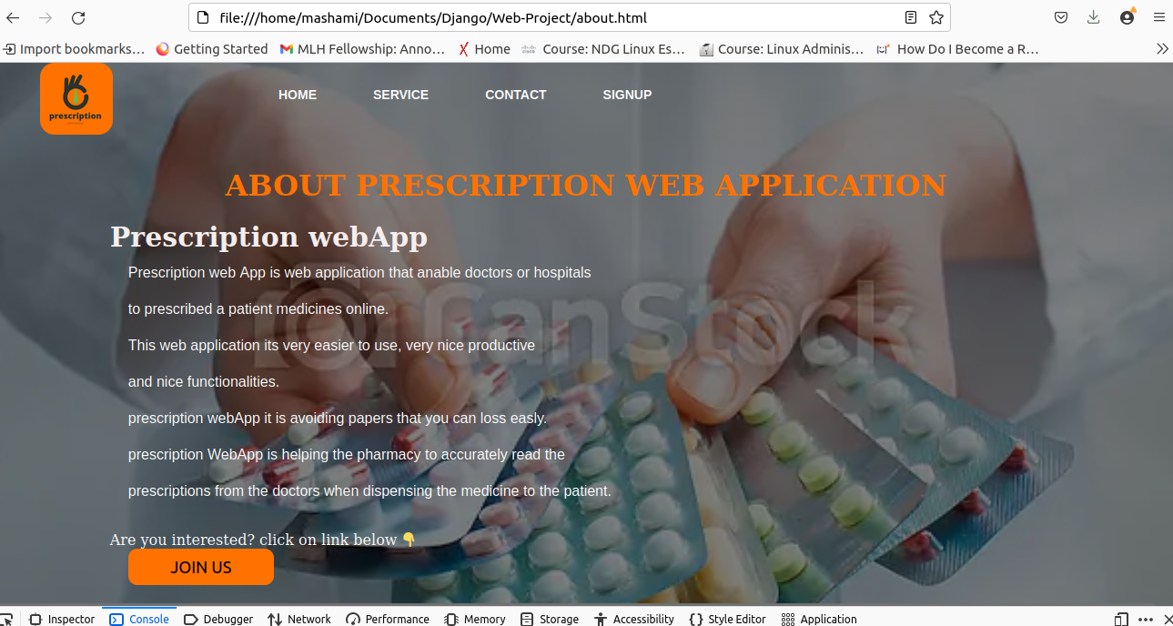

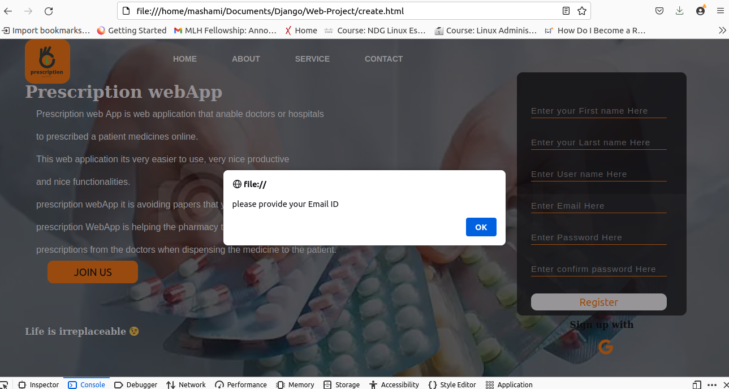

**User will no be allow to sign up or log in without providing Email(javascript validation to all forms )**

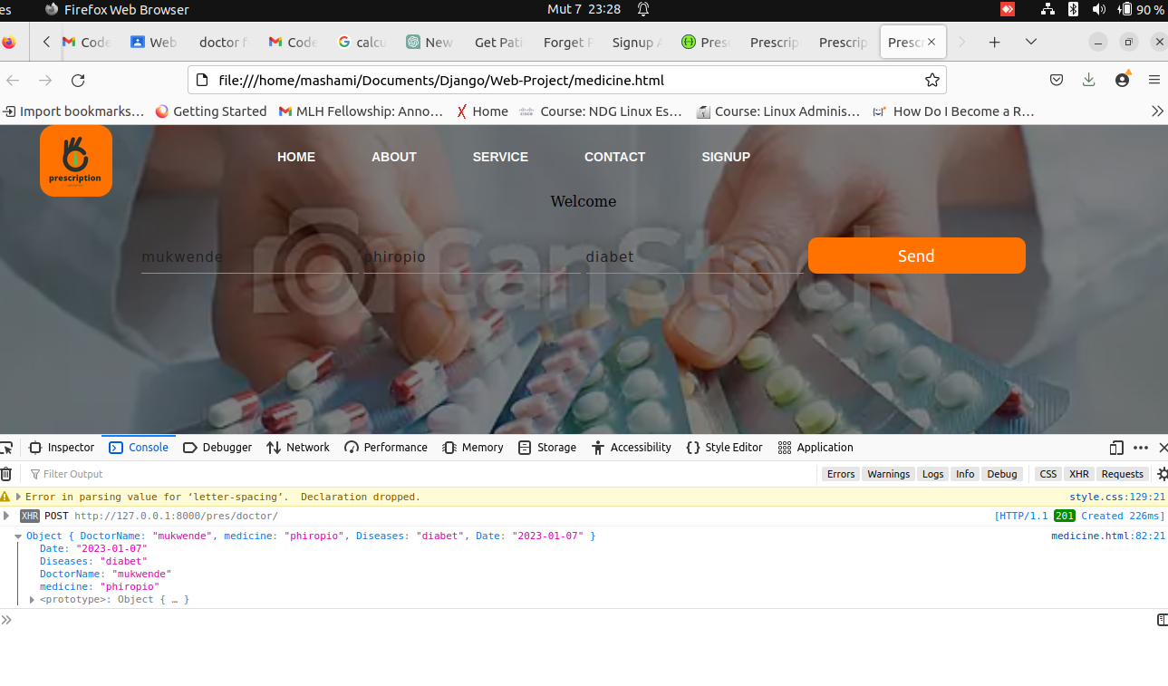**DOCTOR WILL BE ABLE TO MEDICINE A PATIENT**

**Doctor will be able to medicines a patient and saved in database (API “POST”)By using fetch function.**

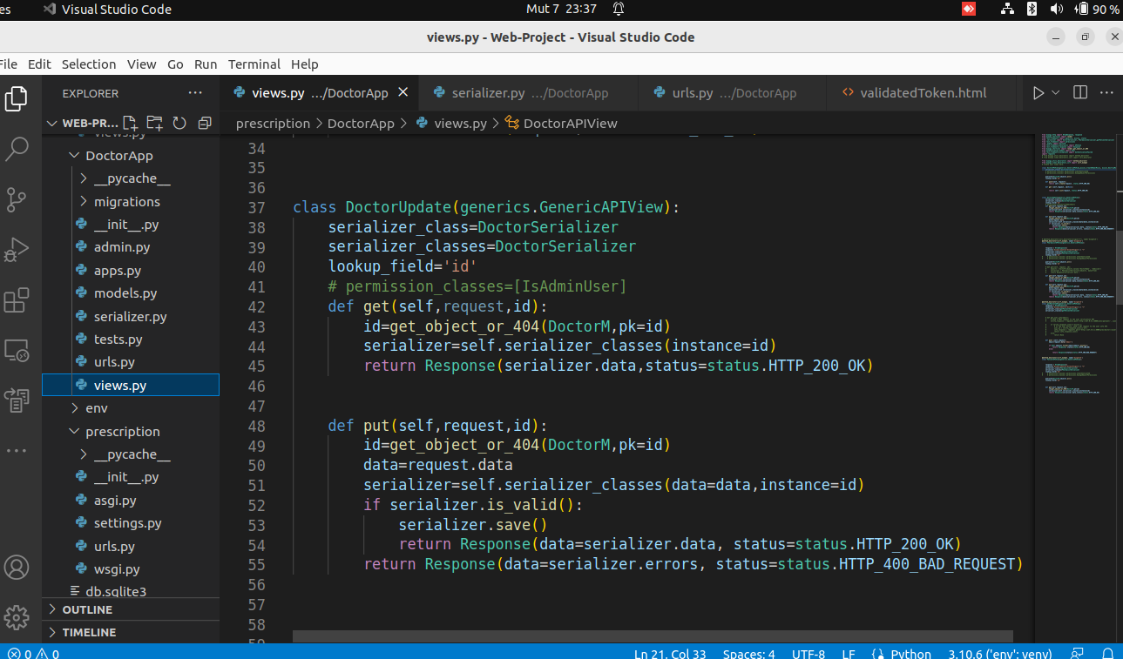

**and will display in table (FETCH API ) By using fetch function. bellow**

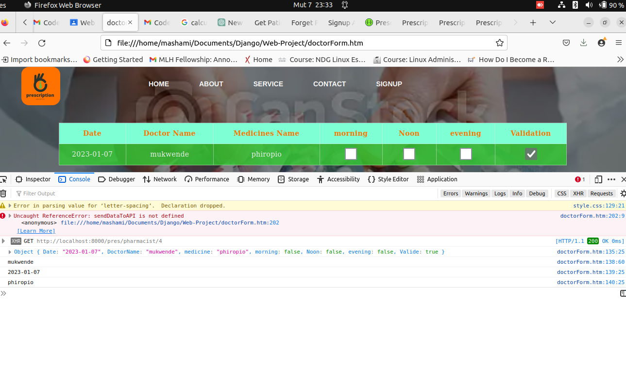

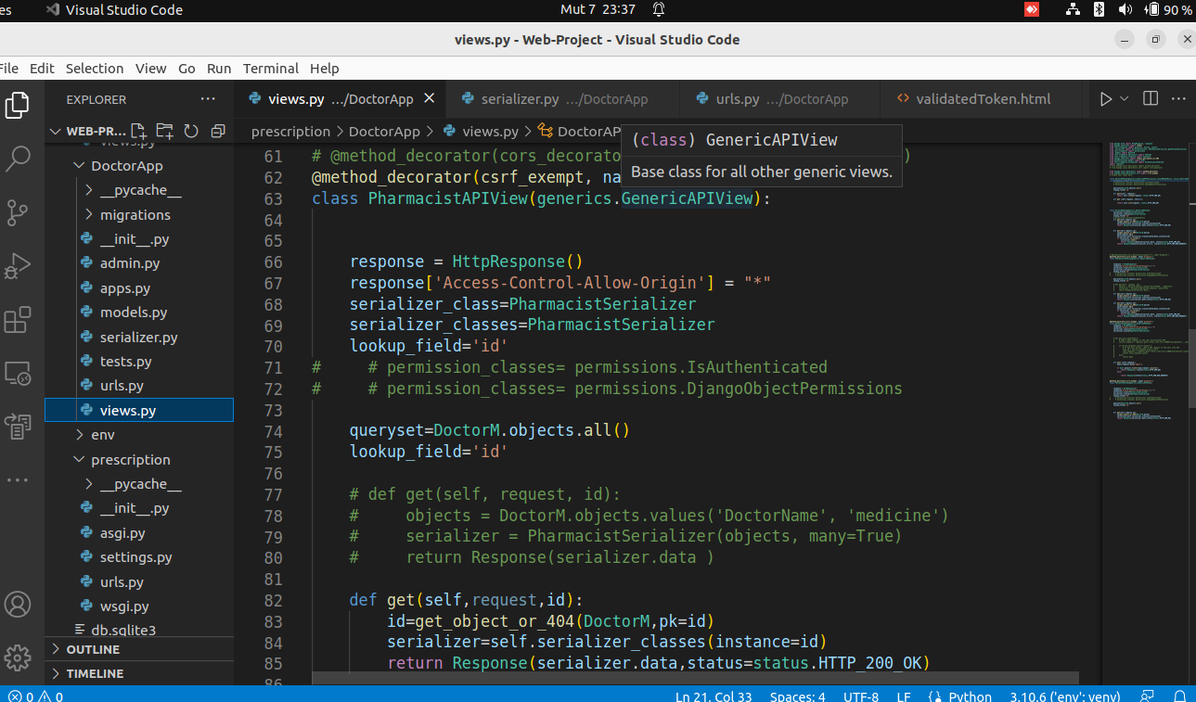

API used to fetch patient medicines.

CSS USED

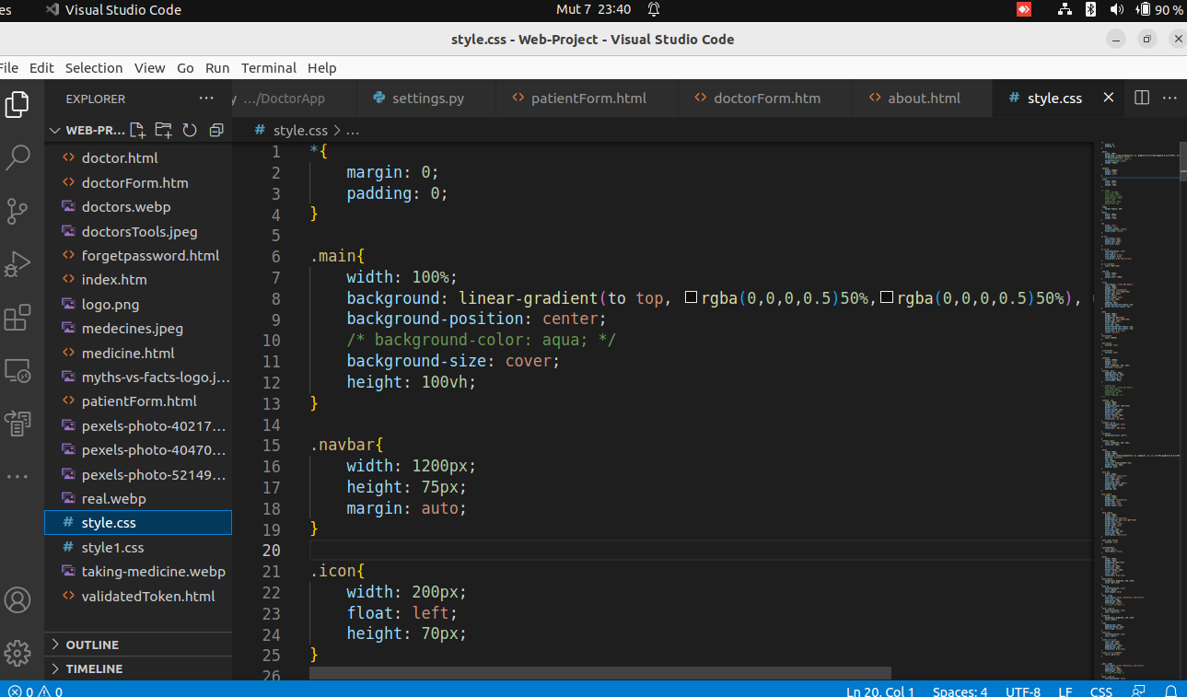

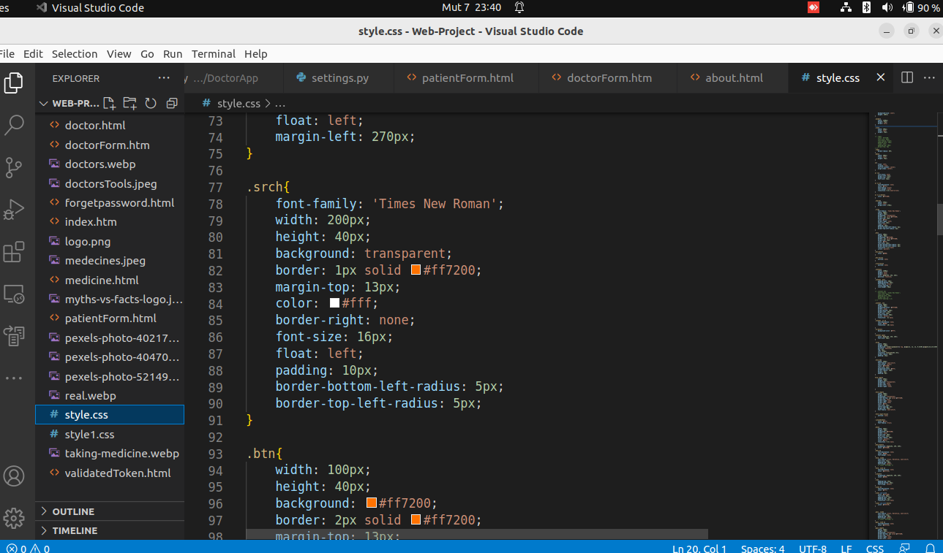

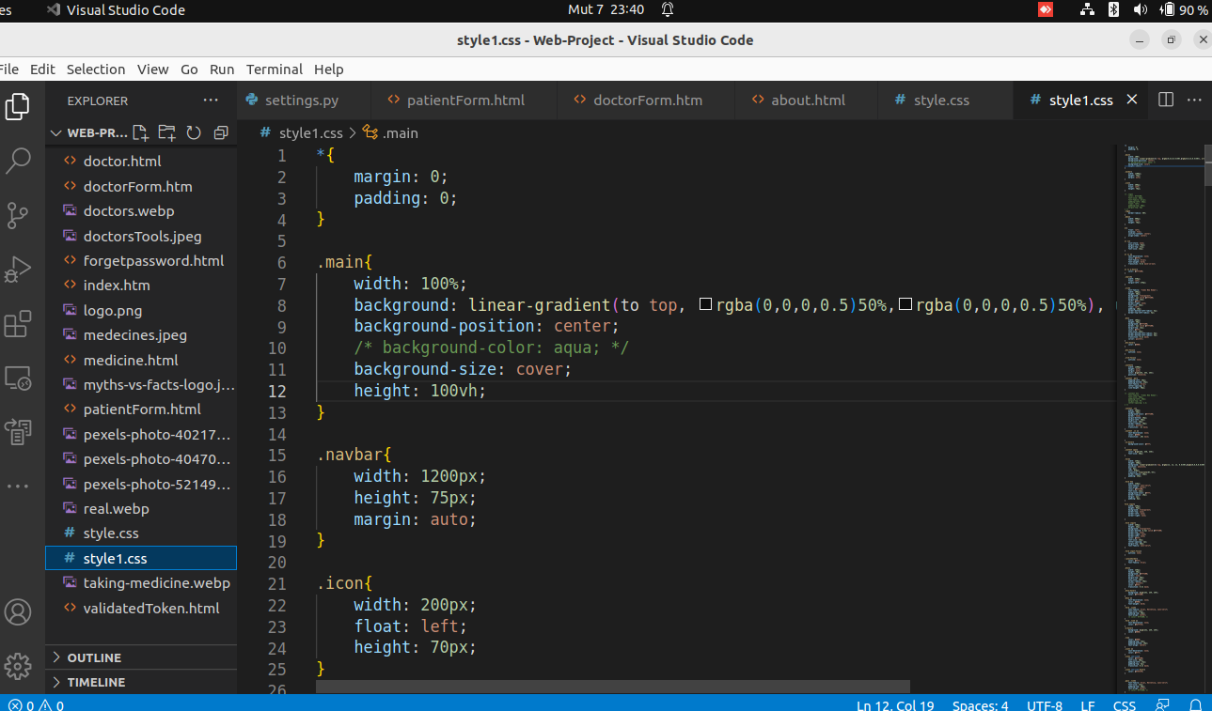

**SWAGGER APIs DOCUMENTATION**

